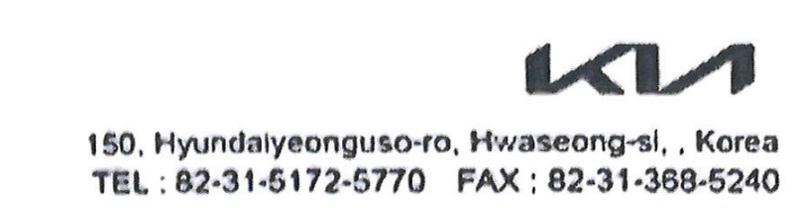


GSO Conformity Certificate CCR No. 567639
Motor Vehicles
Manufacturer: Jiangsu Yueda Kia Automobile Co., Ltd.
Country of Origin: CHINA, Country of Production: CHINA
To: GCC Standardization Organization (GSO)
We hereby certify that the vehicles manufactured by Jiangsu Yueda Kia Automobile Co., Ltd.
* Type: Kia Seltos 1.5L CVT SUV FWD 5Doors
* VlN number: LJD5AA1D*S*******
* Model Year: 2025 * Produced in and after: Month 11 Year 2025
* Category: SUV
Will satisfy the G50 Technical Regulations Nos: 34:20o7, 3s:2007, 36:2005, 37:2012, 38:200s, 392005, 40:2011,42:2015, 48:1984, 51:20o7, 52:2007, 53.2007, 9611988. 9721988, 9811988, 9921988,13522007, 13622007. 29021994. 4119:1994,42o:1994,421:2005,422:200s.1040:20001041:2000,1042:2000,1053:2000,1503:2010,1598:2002,1624:2002,1677:2003,1708:2o0s,1780:2010,1781:2006,1782:2008,1783:2006,1784:2o0e.Gsolso1585:2008,GSO lSO 3537:2008, GSO 150 3538:1997, G50 ECE13H:2012,GSO ECE13H-1:2012,GSO ECE13H-2:2012,GSO ECE 13H-3:2012, GSO ECE13H-4:20l2, GSO ECE13H-S:2012,GSO ECE 13H-6:2012 and the standards in the country of origin accepted by GSO in the case that no GSO technical regulations and standards are available.
All the essential technical data are as follows:
1. Weights
a. Maximum Vehicle Weight: 1670 kg b. Curb: 1255 kg
c. Maximum Axle Weight: Front: 930 kg Rear: 740 kg
2. Dimensions
a. Length: 4385 mm b. Width: 1800 mm
c. Height: 1650 mm d. Wheelbase (Fl R1) 2630 mm e. Track: Front: 1560 mm Rear: 1560 mm
3. Type of chassis and body: Monocoque
4. Number of Passengers: 5(Including the Driver)
5.Engine: Petrol a. Cylinders: 4 b. Displacement: 1497cc c. Air intake: Naturally Aspirated
d. Net Engine Power: 85 kW at 6300 rpm Pollutant Limit comply with Euro 6.
6. Transmission: CVT
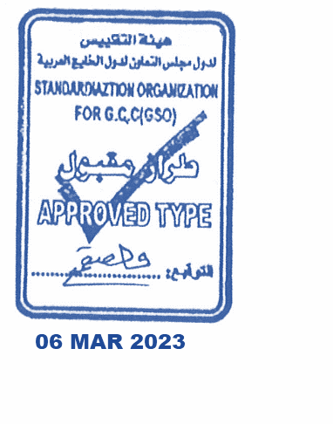
7. Brakes a. Service Brakes: Hydraulic b. Emergency Brakes: Combined with the service brake
8. Fuel Economy a. Motor Vehicle Class: Passenger Car b. FE (CAFE) Combined: 16.5 km/L - Very Good
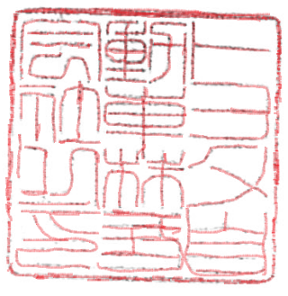
9. Any other information or local standards to be compiled: Also comply with the National regulations for member countries mentioned in the Annex of the list of Technical Regulations for MV 2025 MY-D5, when exporting to those countries.
Keiko Yanagi
general Manager Regulation &Certiﬁcation Division
14 DEC 2025 221020252025

